**OUTLINE**

~ Map Interface ~

Layer1: area divider 1 (base on south-north etc)

Layer2: area divider 2 (base on distance to campus)

Layer3: house price heat map

Layer4: detail info map (price, distance, etc of each apartment)

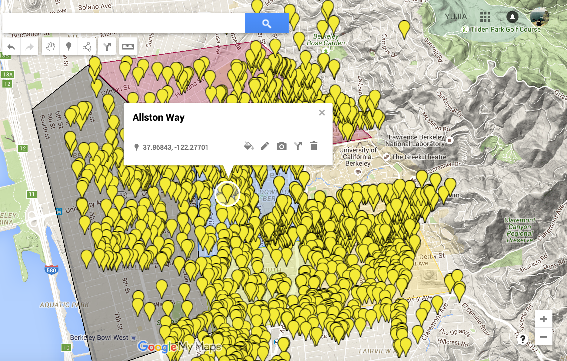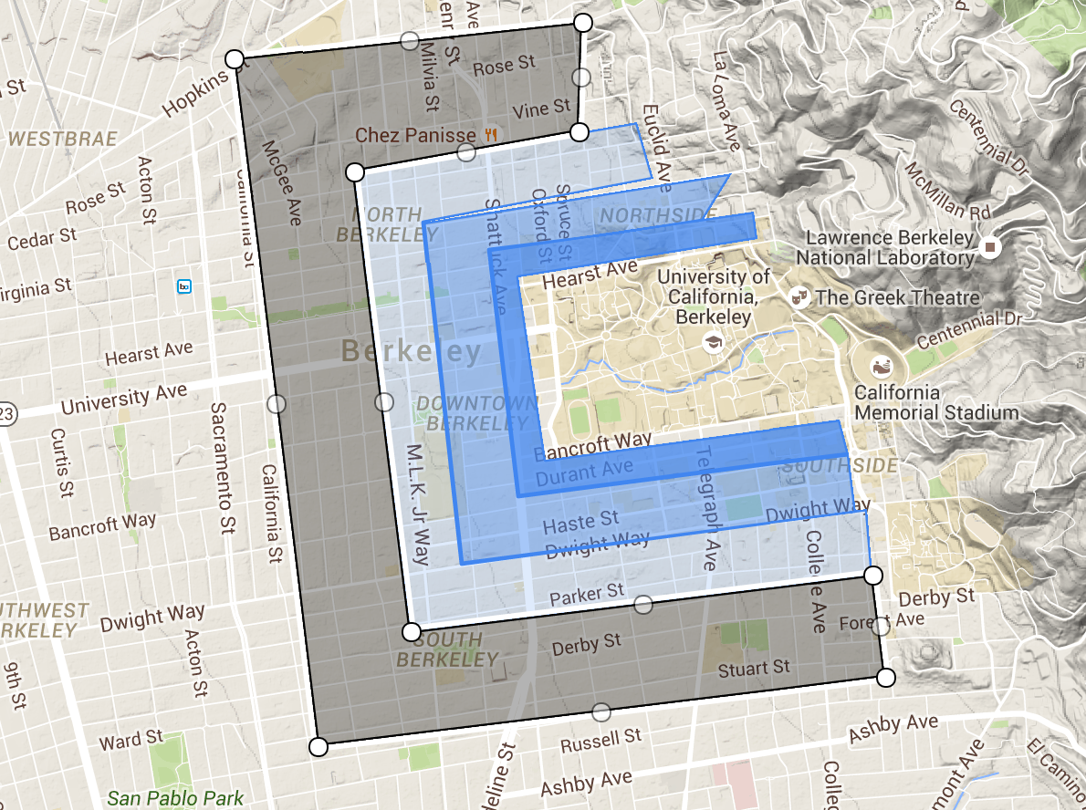

~ House price analysis ~

- Internal

room size(scatter), #Bathroom(box plot), #Shared rooms(box plot),

- Distance from campus (scatter)

- Living quality

(within 2 miles)#Restaurants(scatter), avg rating(scatter), #cafe(box), distance to the closest grocery(scatter)

- Summary

(Optional: crime, transportation)